Name_____________________________________________ Date________ Block______
Exploring Decisions
Cost-Benefit Tree
Before Choice WAS Made - “Assumed” Cost- Benefit Analysis
Costs (Things Given Up) | Benefits (Positive Things Gained)
Choice Outcome - Actual Intended vs. Unintended Consequences
Intended Consequences  (Thought Would Happen & Actually Did) | Unintended Consequences  (Did Not Know Would Happen)

Name_____________________________________________ Date________ Block______
Exploring Decisions
Directions: Use the given sources to help explain the intended and unintended consequences on the Inca Road System.
 | Intended Consequences (Thought would happen and actually did) | Unintended Consequences (Did not know would happen)
Document A
Hernando Pizarro on the Conquest of the Incas
Document B
Las Castas
Document C
Florentine Codex
Document D
Maps
Document E
Pictures of the Inca Road System

Document A
Hernando Pizarro on the Conquest of the Incas
["Letter from Hernando Pizarro to the Royal Audience of Santo Domingo, in Reports on the Discovery of Peru, Clements R. Markham, tr. and ed. (London: Hakluyt Society, 1872), pp. 113-127]

“The Governor continued his march until he came to a town called La Ramada. Up to that point all the land was flat, while all beyond was very rugged and obstructed by very difficult passes. When he saw that the messenger from Atahualpa did not return, he wished to obtain intelligence from some Indians who had come from Cajamarca; so they were tortured, and they then said that they had heard that Atahualpa was waiting for the Governor in the mountains to give him battle. The governor then ordered the troops to advance, leaving the rear-guard in the plain. The rest ascended, and the road was so bad that, in truth, if they had been waiting for us, either in this pass or in another that we came to on the road to Cajamarca, they could very easily have stopped us; for, even by exerting all our skill, we could not have taken our horses by the roads; and neither horse nor foot can cross those mountains except by the roads. The distance across them to Cajamarca is full twenty leagues.”

“The road over the mountains is a thing worth seeing, because, though the ground is so rugged, such beautiful roads could not in truth be found throughout Christendom. The greater part of them is paved. There is a bridge of stone or wood over every stream. We found bridges of network over a very large and powerful river, which we crossed twice, which was a marvellous thing to see. The horses crossed over by them. At each passage they have two bridges, the one by which the common people go over, and the other for the lords of the land and their captains. The approaches are always kept closed, with Indians to guard them. These Indians exact transit dues from all passengers. The chiefs and people of the mountains are more intelligent than those of the coast.”
“After my departure, according to what the Governor writes to me, it became known that Atahualpa had assembled troops to make war on the Christians, and justice was done upon him”

Source: http://www.shsu.edu/~his_ncp/Pizarro.html

Document B
Las Castas: Anonymous, 18th century, oil on canvas, 148x104 cm, Museo Nacional del Virreinato,
Source: http://www.learner.org/courses/globalart/work/85/

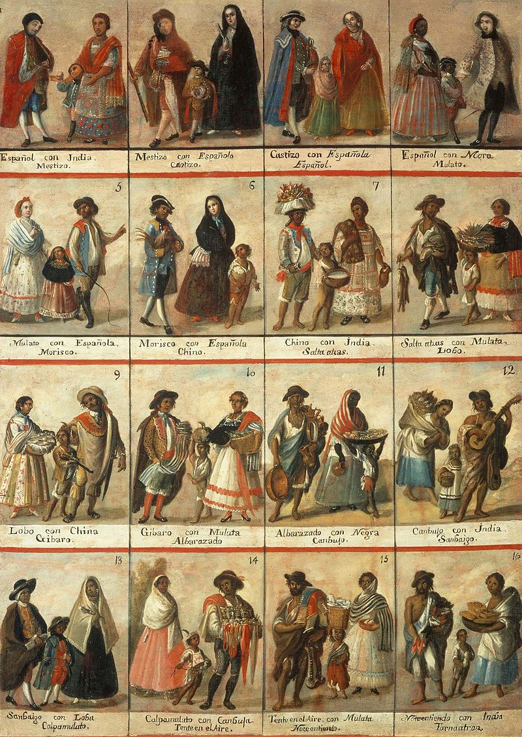

Document C

General History of the Things of New Spain by Fray Bernardino de Sahagún: The Florentine Codex. Book XII: The Conquest of Mexico
Library of Congress
World Digital Library
Source: https://www.wdl.org/en/item/10623/view/1/109/

Document D
The Inca Road System

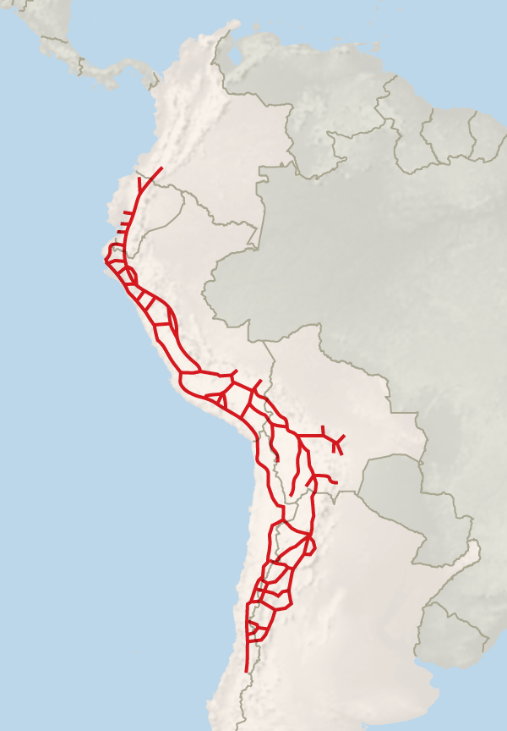Source:http://www.nytimes.com/2014/06/19/arts/design/protection-sought-for-vast-and-ancient-incan-road.html?_r=0

Documents E
The Inca Road System

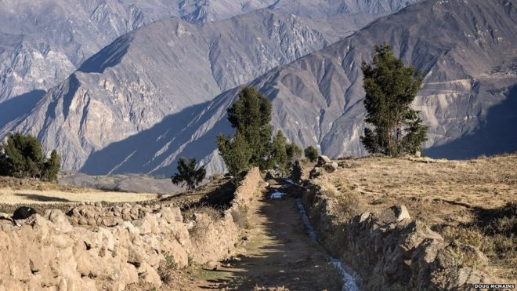
Source:http://www.bbc.com/news/magazine-33291373

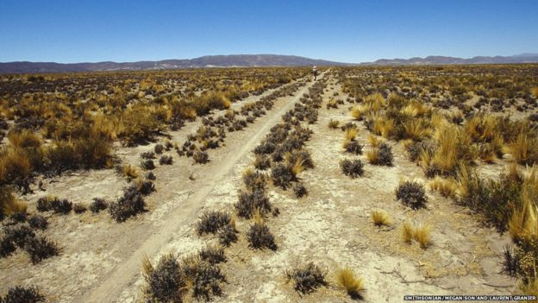
Source:http://www.bbc.com/news/magazine-33291373

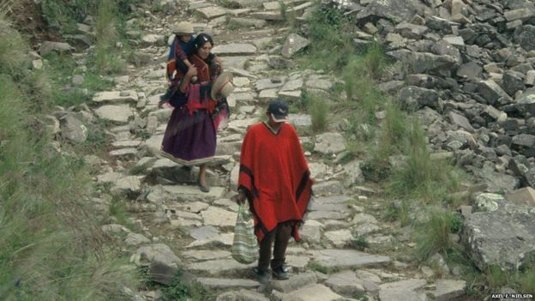
Source:http://www.bbc.com/news/magazine-33291373

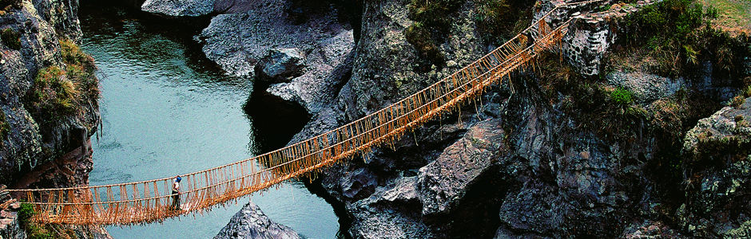
Source: http://www.globaleditorialservices.com/2011/03/the-long-and-winding-road/

